

**PROJECT BASED LEARNING (PBL-1) LAB (CSP254)**

**Chat-Bot Assistant**

**B.TECH 2nd YEAR**

**SEMESTER: 3rd**

**SESSION: 2024-2025**

**DEPARTMENT OF COMPUTER SCIENCE & ENGINEERING**

**SHARDA UNIVERSITY, GREATER NOIDA**

**Submitted By:**

**Name: Suryansh Rai**

**Roll No / System ID: 2023489679**

**Section: CS-E(G1)**

**Submitted To:**

**Dr. Nidhi Gupta**

**Assistant Professor CSE [SSET]**

**Table Of Contents**

| **S.No** | **Title** | ***P*age No.** |
| --- | --- | --- |
| 1 | Project Title | 1 |
| 2 | Team Details | 1 |
| 3 | Technologies |  |
| 3.1 | Software | 3 |
| 3.2 | Hardware | 3 |
| 3.3 | Tools | 4 |
| 4 | Problem Statement | 5 |
| 5 | Literature Survey | 5 |
| 6 | Project Description | 6 |
| 7 | Project Design & Algorithms | 7 |
| 8 | Implementation Methodology | 10 |
| 9 | Result & Conclusion | 12 |
| 10 | Future Scope | 13 |
| 11 | Advantages | 13 |
| 12 | Outcome | 14 |
| 13 | References | 14 |

**1. Chat-Bot Assistant**

**2. Team Details:**

|  |  |  |  |  |
| --- | --- | --- | --- | --- |
| **S. No** | **Student Name** | **Roll Number** | **System ID** | **Role** |
| **1** | **Suryansh Rai** | **2301010887** | **2023489679** | **Developer, Tester** |
| **2** | **Sujay Kumar** | **2301010870** | **2023518586** | **Designer, Tester** |

**3. Technologies to be Used**

The project leverages modern web technologies to create a robust and interactive chatbot interface. The core technologies include HTML, CSS, and JavaScript for the frontend, enabling a visually appealing and responsive user experience. For the backend, JavaScript-based server-side logic will handle user input and response generation. Tools for voice synthesis and text matching algorithms are integrated to enhance interactivity and accuracy. Future scalability allows the integration of advanced AI technologies like NLP for improved conversational depth.

**3.1 Software Platform**

**Frontend**

**Technologies:**

* HTML for structuring the chatbot interface.
* CSS for styling and ensuring a responsive design.
* JavaScript for dynamic functionalities and interactivity.

**Backend**

**Technologies:**

* Basic JavaScript for now, without requiring an advanced backend framework.

**Browser**

The project runs seamlessly on modern web browsers like Google Chrome, Mozilla Firefox, or Microsoft Edge, ensuring cross-platform compatibility.

**3.2 Hardware Platform**

To run the project effectively, the following hardware specifications are recommended:

* RAM: Minimum 4 GB (8 GB or higher for optimal performance).
* Hard Disk: Minimum 100 MB free space for code files, dependencies, and assets.
* Operating System: Windows 10/11, macOS, or a Linux-based system.
* Editor: Visual Studio Code (preferred) for its lightweight interface and extensive plugin support.
* Browser: Latest versions of Chrome, Firefox, or Edge for testing and deployment.

**3.3 Tools**

Various tools will be utilized during the project lifecycle to ensure streamlined development and maintenance:

* Code Editor:
  + Tool Name: Visual Studio Code
  + Vendor: Microsoft
  + Version: Latest version (stable build)
* Version Control:
  + Tool Name: Git
  + Vendor: GitHub
  + Version: 2.4 or higher
  + Purpose: To manage and track code changes, collaborate efficiently, and ensure version history is maintained.
* Testing Tools (if applicable):
  + Tool Name: Chrome DevTools
  + Vendor: Google Chrome
  + Purpose: Debugging and performance testing of the chatbot in the browser.

**4. Problem Statement**

In today’s fast-paced digital environment, providing efficient and consistent communication has become a significant challenge for institutions. Traditional methods of addressing inquiries are often time-consuming, limited by staff availability, and unable to meet the demands of a growing user base. This project addresses these challenges by introducing an AI chatbot assistant.

The AI chatbot is designed to streamline communication, reducing the workload on staff and allowing them to focus on more complex tasks. It provides 24/7 assistance, ensuring users receive timely support, enhancing engagement, and improving satisfaction. Its scalability ensures it can handle increasing inquiries without compromising performance. Furthermore, multilingual support enables inclusivity by catering to a diverse population, making it a versatile and impactful solution for modern communication needs.

**5. Literature Survey**

|  |  |  |  |  |  |  |
| --- | --- | --- | --- | --- | --- | --- |
| **Year** | **Authors** | **Title** | **Technology/ Methodology Used** | **Advantages** | **Limitations** | **Dataset Used (if any)** |
| **2018** | Kumar Shivam et al. | Chatbot for College Website | AI, AIML, Facebook Messenger API, Python, WIT.AI | Reduces workload, provides 24x7 info access | Limited query handling, relies on pre-trained models | Custom modules for college queries |
| **2020** | Sue Inn Ch'ng, Lee Seng Yeong, Xin-Yean Ang | Preliminary Findings of using Chat-bots as a Course FAQ Tool | Google Dialogflow, Telegram | Automates FAQs, improves response time, centralizes information | Requires updates for changing info, mixed user preferences | Questions from Padlet, chat-bot conversation logs. |
| **2020** | Minh-Tien Nguyen et al. | Chatbot for University Admissions | Rasa platform, DIET | Automates admissions, 24/7 support | Performance varies, small dataset | N/A |
| **2021** | Rohan Parkar, Yash Payare, Keyur Mithari, Jitesh Nambiar, Jaya Gupta | AI And Web-Based Interactive College Enquiry Chatbot | Natural Language Processing (NLP), Feedforward Neural Network, HTML, PHP, JavaScript, Flask-SocketIO | Automates responses to college-related queries, reduces need for personal visits, updates information dynamically, improves efficiency | Struggle with complex or twisted queries if not well-trained, relies on a well-maintained database. | JSON format dataset with intents, tags, and response patterns. |

|  |  |  |  |  |  |  |
| --- | --- | --- | --- | --- | --- | --- |
| **2021** | Mohamad Ali Hamade et al. | Building a Chatbot for Supporting University Admissions | NLP and machine learning | 24/7 support, reduces staff workload | Data quality limits effectiveness | University admission data |

|  |  |  |  |  |  |  |
| --- | --- | --- | --- | --- | --- | --- |
| **2022** | Krishna Kumar Nirala, Nikhil Kumar Singh, & Vinay Shivshanker Purani | A survey on providing customer and public administration based services using AI: chatbot | Discusses soft-computing techniques, rule-based and AI models, machine vision for cyber-physical systems | Highlights potential of AI-assisted chatbot systems for customer services and public administration | Not explored public administration services, need for improvement in NLP and ML algorithms | N/A |
| **2023** | A. Niam Ibna Riza, Indiana Hidayah, Paulus Insap Santosa | AI Chatbot for E-Learning | NLP, Ontology-based Knowledge Management, Petri Net, LDA Algorithm | Real-time assistance, reduces teacher workload, personalized learning, multimedia feedback | Struggles with ambiguous queries, cognitive shifts, incorrect suggestions | 165 and 125 students from two university courses |
| **2023** | Peter Adebowale Olujimi, Abejide Ade-Ibijola | NLP techniques for automating responses to customer queries: a systematic review | Chatbots, NLP Techniques (Sentiment Analysis, Named Entity Recognition, Language Translation, Pre-trained Models) | Improved customer satisfaction Cost minimization Accurate information translation Enhanced consumer feedback analysis | Data ambiguities (polysemy, homonyms, synonyms) Information overload Domain-specific language issues | N/A |

**6. Project Description**

This project involves the development of an AI-based chatbot designed to provide seamless and efficient interaction for users. The chatbot acts as a conversational interface to handle queries, provide information, and ensure user engagement in real-time. The project aims to deliver a user-friendly, interactive solution adaptable for various use cases, such as student support, customer assistance, or general queries.

**Scope of Work**

1. **Design and Development**: Building a chatbot capable of understanding user input, providing relevant responses, and engaging in meaningful conversations.
2. **Integration**: Connecting the chatbot with a frontend interface and backend server for seamless operation.
3. **Testing and Deployment**: Ensuring the chatbot operates as expected across various scenarios and deploying it on a chosen platform for public use.
4. **Scalability**: Designing the system to handle growing user traffic and integrate additional features as required.

**Structure of the Project**

The project is divided into the following modules:

1. **User Interface (UI)**: A frontend interface allowing users to interact with the chatbot.
2. **Core Chatbot Logic**: The heart of the system, enabling the chatbot to interpret user input and generate appropriate responses.
3. **Database Management**: A backend database for storing frequently asked questions, responses, and analytics.
4. **Voice Interaction Module**: (Optional) Adding voice-based interaction for better accessibility and user experience.

**Context Diagram**

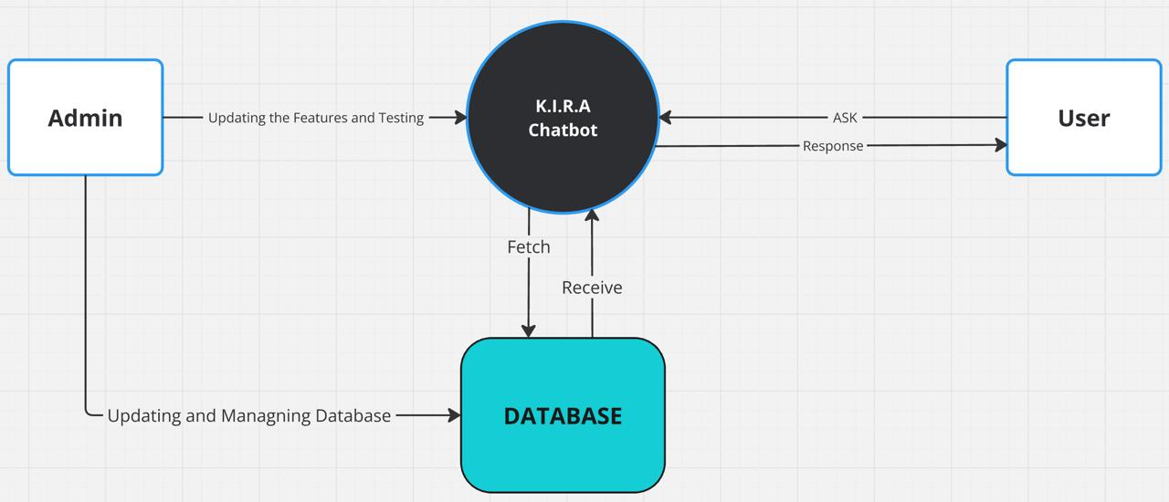**Fig.1.** Workflow of the Bot

**7. Project Modules: Design/Algorithm**

The project consists of several interconnected modules, each playing a crucial role in the functioning of the AI chatbot. Below is an overview of the modules and their functions:

**1. User Interface (UI) Module**

* **Description**: The frontend module allows users to interact with the chatbot through text-based inputs or optional voice commands. It provides a visually appealing interface with dynamic typing animations, input fields, and display areas for bot responses.
* **Key Features**:
  + Text input and display area for conversations.
  + Optional voice input/output (if integrated).
  + Mobile-friendly and responsive design.

**2. Input Processing Module**

* **Description**: This module is responsible for processing the user input to understand the query's intent. If the bot does not use advanced NLP, simpler techniques such as keyword matching or rule-based responses are applied.
* **Algorithm**:
  + Accepts user input and preprocesses it (e.g., trimming spaces, removing special characters).
  + Matches keywords from user input with a predefined set of responses.
  + Passes the processed input to the response generation module.

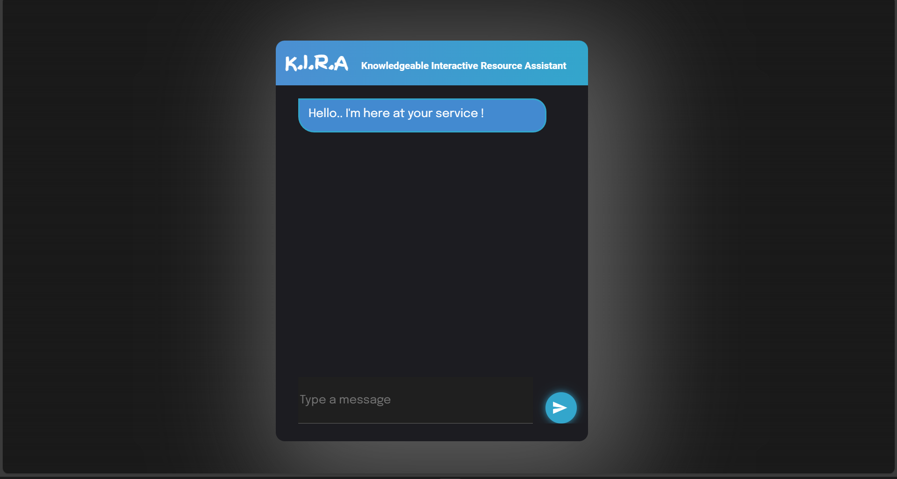

Fig.2. Landing UI of the Bot

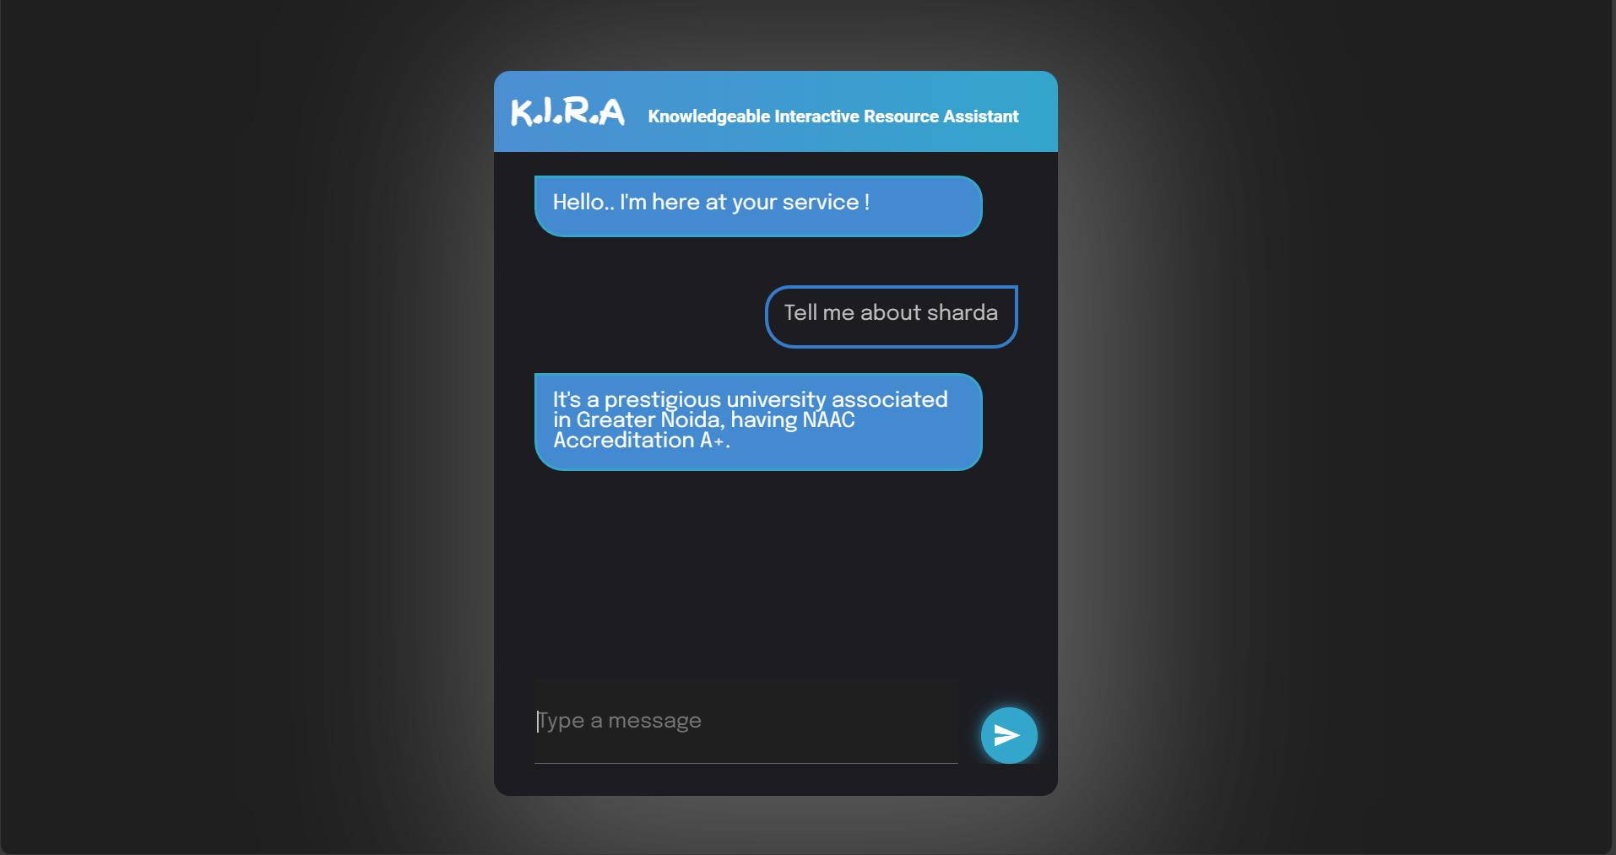

Fig.3.The Bot Replying

**3. Core Logic/Response Generation Module**

* **Description**: The core of the chatbot, responsible for generating appropriate responses based on user queries. It uses pre-defined rules or an intent-matching algorithm to determine the best reply.
* **Key Processes**:
  + Matches the user's intent with the available database of intents and responses.
  + For unmatched queries, directs the user to a fallback response or predefined help message.

**4. Database/Knowledge Base Module**

* **Description**: A backend repository that stores frequently asked questions (FAQs), responses, and user data.
* **Purpose**:
  + Retrieve accurate responses for user queries.
  + Ensure scalability by allowing easy updates to the database as the chatbot evolves.

**5. Analytics and Logging Module**

* **Description**: Tracks user interactions with the chatbot to provide insights and improve functionality over time.
* **Key Features**:
  + Logs all user inputs and bot responses for analysis.
  + Tracks frequently asked queries to update the database and improve accuracy.
  + Monitors system performance for scalability purposes.

**6. Testing and Debugging Module**

* **Description**: This module ensures the chatbot works seamlessly across all scenarios by identifying bugs and inefficiencies during development.
* **Purpose**:
  + Simulate user interactions for performance testing.
  + Validate accuracy and relevance of responses.
  + Fix any identified bugs or incorrect behaviors.

**7. Deployment Module**

* **Description**: Handles the integration of the chatbot into the selected platform (e.g., a website, mobile app, or standalone application).
* **Tasks**:
  + Connects frontend and backend components for real-time operation.
  + Deploys the chatbot on a hosting server or cloud platform.
  + Monitors live performance post-deployment.

**Algorithm Overview**

While no advanced NLP is being used, the chatbot relies on:

1. **Keyword Matching**:
   * The input text is scanned for keywords.
   * Based on identified keywords, a relevant predefined response is retrieved.
2. **Rule-Based Response**:
   * If specific patterns or keywords are detected in the input, a corresponding response is generated from the database.
3. **Fallback Mechanism**:
   * If no keyword match is found, the chatbot provides a default or help message.

**8. Implementation Methodology**

The development of the AI Chatbot Assistant follows a structured process, encompassing system design, implementation, testing, and maintenance. This methodology ensures efficient operation and scalability while maintaining user satisfaction. Below is the detailed outline:

**1. Requirement Analysis**

* Gather and document user requirements for the chatbot’s functionality.
* Define the chatbot’s scope, focusing on the types of queries it will handle.
* Establish a clear understanding of the technologies, tools, and hardware to be used.

**2. System Design**

* **Data Flow Diagram (DFD):** Illustrates the process flow:
  1. User inputs a query.
  2. The chatbot processes and analyzes the input.
  3. A relevant response is generated and displayed to the user.
* **Use Case Diagram:** Visualizes interactions between the user and the chatbot.
* **Class Diagram:** Represents the structure of the project, including classes for queries, responses, and database interactions.
* **Flowchart:** Outlines the flow of information:
  1. Input → Preprocessing → Response Matching → Output.
  2. Fallback mechanism for unmatched queries.

**3. Development Process**

1. **Frontend Development**:
   * Create an interactive user interface using **HTML**, **CSS**, and **JavaScript**.
   * Implement features such as dynamic typing animations for a conversational feel.
2. **Backend Development**:
   * Use **Python** to process user inputs and generate responses.
   * Implement a rule-based response system or decision tree for initial functionality.
3. **Database Integration**:
   * Utilize a database (e.g., SQLite) to store predefined intents, responses, and logs of user interactions.

**4. Implementation Workflow**

* **Input Processing**: Accept and preprocess user inputs (e.g., removing unnecessary characters or words).
* **Keyword/Intent Matching**: Match user queries to a database of predefined responses using basic keyword matching algorithms.
* **Response Generation**: Retrieve appropriate responses or fallback messages if no match is found.
* **User Feedback Loop**: Log interactions and provide mechanisms for user feedback to improve the chatbot’s performance over time.

**5. Testing**

Testing is critical to ensure reliability and accuracy:

1. **Unit Testing**:
   * Test individual modules like response matching and input processing.
2. **Integration Testing**:
   * Ensure smooth interaction between the frontend, backend, and database.
3. **System Testing**:
   * Validate the chatbot's functionality as a complete system.
4. **User Acceptance Testing**:
   * Conduct trials with real users to gather feedback on usability and accuracy.

**Defect Log Maintenance**:

* Maintain a log to record defects, assign priority levels, and track resolutions.
* Use tools like **Jira** or **Trello** for defect tracking and management.

**6. Maintenance and Scalability**

* Update the database regularly to accommodate new queries and responses.
* Monitor performance and user feedback to address issues promptly.
* Scale the system to handle increased user loads as the chatbot’s usage grows.

**Example Diagrams**

1. **DFD**:
   * User → Input → Preprocessing → Response Matching → Response Output.
2. **ER Diagram**:
   * **Entities**: Users, Queries, Responses.
   * **Relationships**: Users interact with queries; queries fetch responses from the database.
3. **Use Case Diagram**:
   * **Actors**: User, Chatbot.
   * **Interactions**: Submitting a query, receiving a response, providing feedback.

**9. Result and Conclusion**

The AI Chatbot Assistant project successfully demonstrates the potential of technology to enhance communication and user interaction in a variety of contexts. By providing a responsive, easy-to-use interface and leveraging fundamental programming concepts, the chatbot achieves its goal of simplifying user queries and delivering instant responses.

The primary achievements of the project include:

* **Seamless User Interaction**: A well-designed frontend ensures an intuitive and engaging user experience.
* **Accuracy in Response Matching**: The chatbot effectively handles a variety of user queries using a structured database and decision-tree logic.
* **Scalability and Flexibility**: The modular design of the project allows for easy updates and integration of additional functionalities in the future.

This project stands out due to its focus on user-centric design, simplicity, and adaptability. It provides a solid foundation for further innovations, such as the integration of Natural Language Processing (NLP), voice synthesis, and multilingual support. The implementation process not only highlights the practical application of software development skills but also underscores the importance of creating accessible and functional solutions for modern-day problems.

**10. Future Scope and Further Enhancements of the Project**

The AI Chatbot Assistant project has immense potential for growth and enhancement. As the current implementation lays a strong foundation, several features and functionalities can be added in the future to improve its usability, efficiency, and scope of application. Some of the key areas for enhancement include:

* **Integration of Natural Language Processing (NLP):**  
  Incorporating NLP capabilities will enable the chatbot to understand user queries more effectively, including complex sentences, slang, and contextual meanings. This will significantly enhance user interaction by making responses more intuitive and accurate.
* **Voice-Based Interaction:**  
  Adding speech recognition and voice synthesis functionalities can make the chatbot accessible to a wider audience, including individuals with visual impairments or those who prefer hands-free interaction.
* **Multilingual Support:**  
  By enabling multilingual capabilities, the chatbot can cater to users from diverse linguistic backgrounds, increasing its applicability in global settings.
* **Enhanced Database and Learning Capabilities:**  
  Implementing machine learning algorithms will allow the chatbot to improve its responses over time by learning from past interactions. Additionally, expanding the database can help cover a broader range of queries.
* **Integration with Third-Party Services:**  
  Connecting the chatbot with APIs for services like weather updates, appointment scheduling, or e-commerce platforms can provide added convenience and utility to users.
* **Deployment on Multiple Platforms:**  
  Extending the chatbot’s presence across various platforms, such as mobile apps, social media, and messaging services, will ensure wider reach and accessibility.
* **Advanced User Analytics:**  
  Incorporating data analytics features will allow tracking user behaviour and preferences. This can provide valuable insights for continuous improvement of the system.
* **Improved Security Measures:**  
  Enhancing data encryption and implementing user authentication methods will ensure the secure handling of sensitive user information, particularly in applications involving personal or financial data.

**11. Advantages of this Project**

The AI Chatbot Assistant offers several advantages that make it a valuable addition to modern technological solutions. These benefits cater to both the end-users and organizations deploying the system. Key advantages include:

* **Streamlined Communication:**  
  By automating responses to common queries, the chatbot reduces response time and enhances user experience, offering instant solutions to users.
* **Reduces Workload:**  
  For organizations, the chatbot minimizes the workload on staff by handling repetitive tasks, allowing human resources to focus on more complex or critical issues.
* **Scalability:**  
  The system can handle multiple users simultaneously without performance degradation, making it suitable for organizations with high volumes of inquiries.
* **Cost Efficiency:**  
  Deploying a chatbot reduces the need for extensive customer support teams, leading to long-term cost savings for businesses.
* **User Engagement:**  
  Interactive features, such as dynamic responses and personalized recommendations, keep users engaged and improve overall experience.
* **Multidomain Applicability:**  
  The chatbot can be adapted to a variety of industries, including education, healthcare, customer service, and e-commerce, benefiting a wide audience.
* **Ease of Access:**  
  By integrating with various platforms like websites, mobile apps, or messaging systems, the chatbot ensures that users can access it from anywhere, enhancing convenience.
* **Personalization:**  
  The chatbot can provide tailored responses based on user preferences and behavior, making interactions more relevant and effective.
* **Enhanced User Satisfaction:**  
  Quick responses, accurate information, and an engaging interface contribute to a positive user experience, ultimately boosting satisfaction and loyalty.

**12. Outcome**

The AI Chatbot Assistant was successfully developed and presented at a hackathon, showcasing its ability to deliver real-time responses and provide seamless user interactions. The project resulted in a functional prototype, positive feedback from judges and peers, and valuable skill development in coding, UI/UX design, and teamwork. It demonstrated innovative features, practical applications, and potential scalability for real-world use.

**13. References**

1. **A survey on providing customer and public administration based services using AI: chatbot**

[**https://link.springer.com/article/10.1007/s11042-021-11458-y**](https://link.springer.com/article/10.1007/s11042-021-11458-y)

1. **Building a Chatbot for Supporting the Admission of Universities**

[**Building a Chatbot for Supporting the Admission of Universities (researchgate.net)**](https://www.researchgate.net/publication/357082032_Building_a_Chatbot_for_Supporting_the_Admission_of_Universities)

1. **NEU-chatbot: Chatbot for admission of National Economics University**

[NEU-chatbot: Chatbot for admission of National Economics University - ScienceDirect](https://www.sciencedirect.com/science/article/pii/S2666920X21000308)

1. **A Study on Chatbots and Virtual Assistants in Customer Engagement: A Review**

[A Study on Chatbots and Virtual Assistants in Customer Engagement: A Review (researchgate.net)](https://www.researchgate.net/publication/378775661_A_Study_on_Chatbots_and_Virtual_Assistants_in_Customer_Engagement_A_Review)

1. **Enhancing Student Support and Engagement with Natural Language Processing in Academic Chatbot's**

[Enhancing Student Support and Engagement with Natural Language Processing in Academic Chatbot's | IEEE Conference Publication | IEEE Xplore](https://ieeexplore.ieee.org/document/10434637)

1. **Chat-Bot For College Management System Using A.I**

<https://tinyurl.com/7h3u475s>

1. **AI And Web-Based Interactive College Enquiry Chatbot**

[**AI And Web-Based Interactive College Enquiry Chatbot | IEEE Conference Publication | IEEE Xplore**](https://ieeexplore.ieee.org/abstract/document/9515065)